**Assignment-2**

**Name:-** R Sujith

**Reg No:-** 21BCE7696

**Course:-** Data Analytics collaboration with ibm

Cognos

**Branch:-** VIT-AP(Amravati)

**Challenge:-**

Upload the dataset to Cognos Analytics, prepare the data, explore and Create Interactive Dashboard, Report and Story.

**Data Module: -**

**First, we upload the dataset and add to the data module for changes or some operations.**

**Explore:-**

**Bar Chart:-**

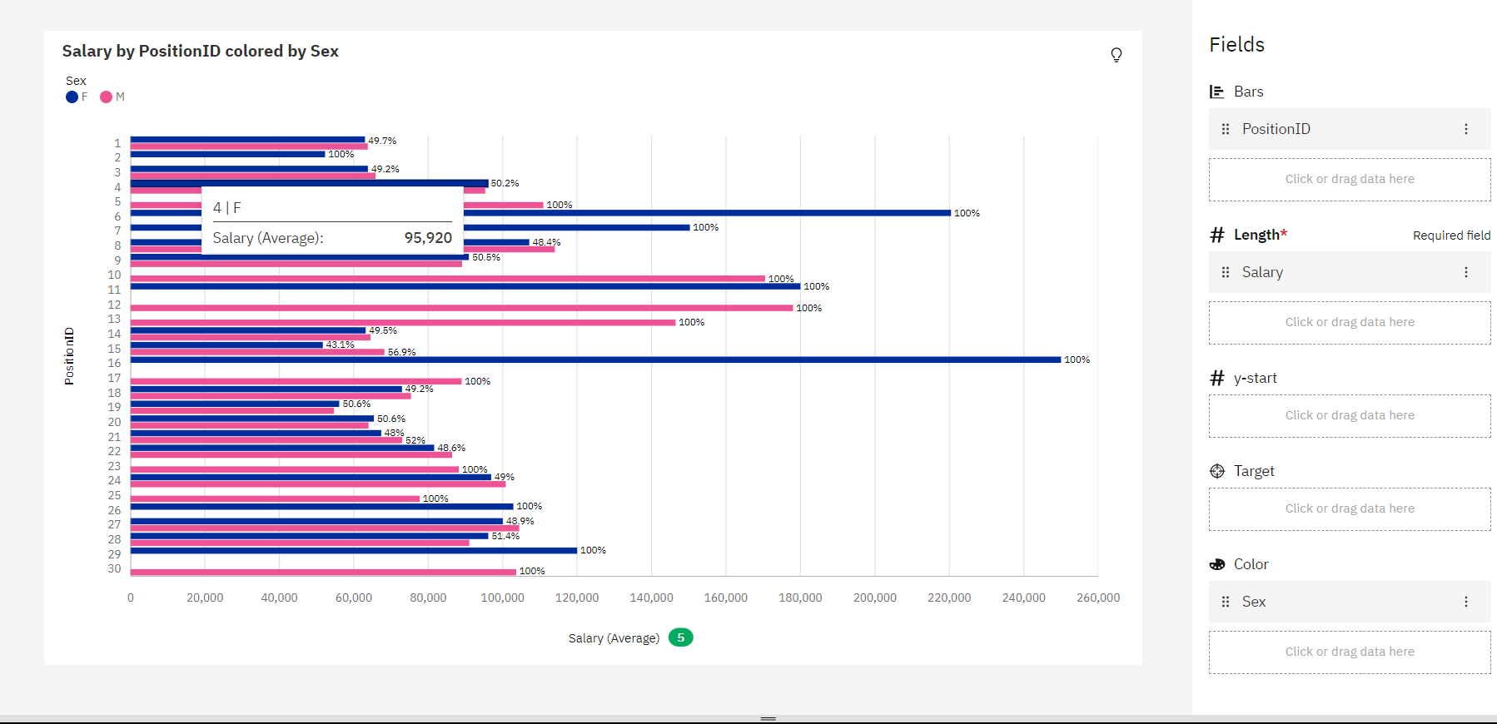

**Pie Chart: -**

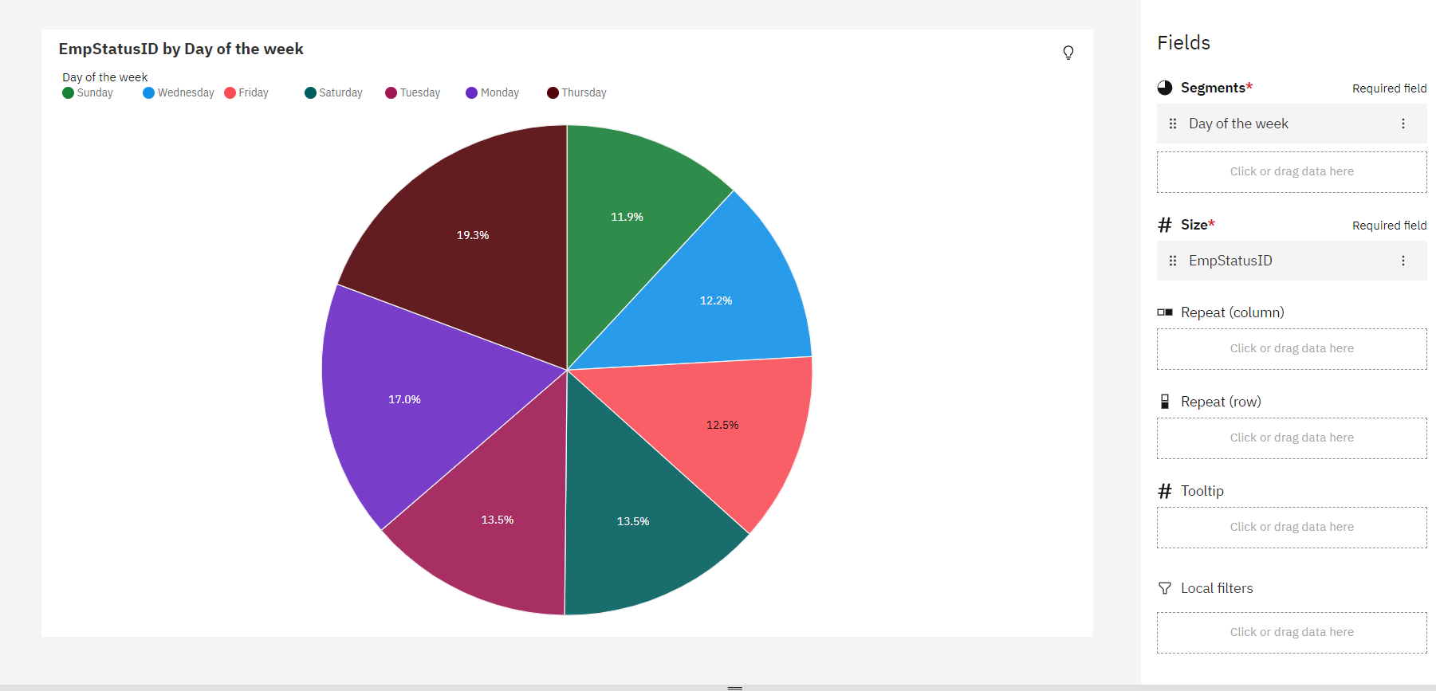

**Map Chart: -**

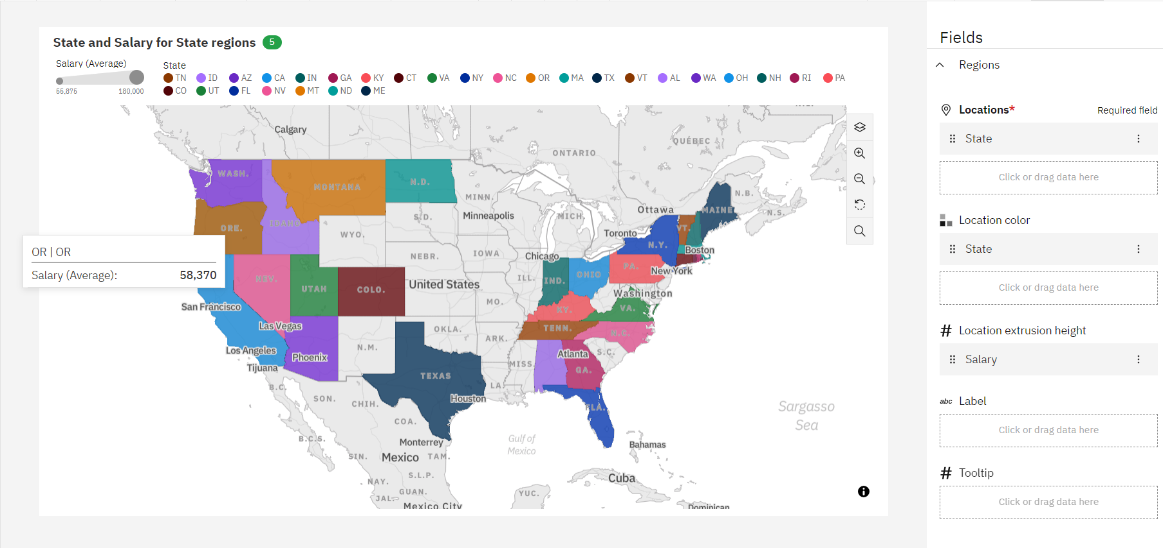

**Area Chart: -**

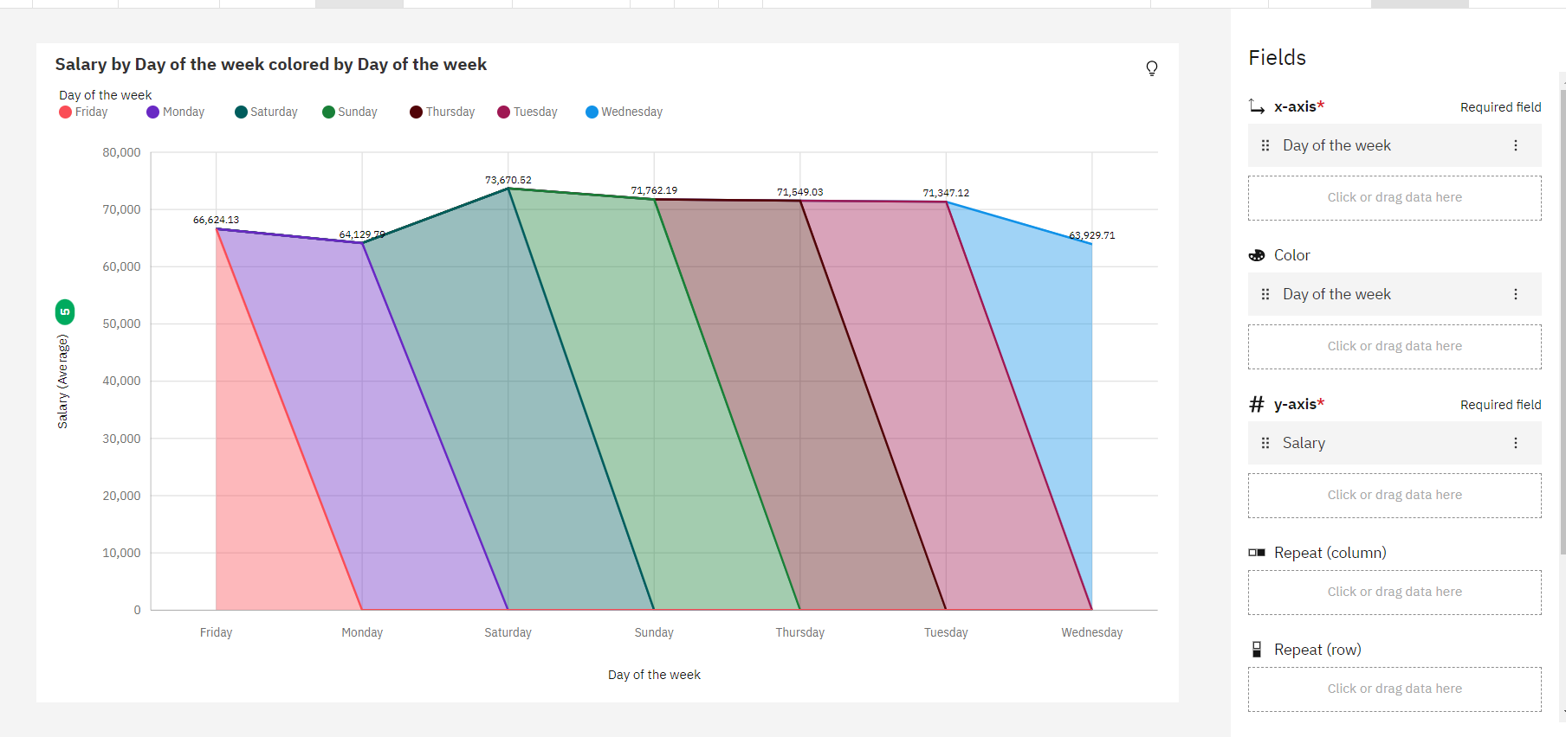

**Stacked Column Chart: -**

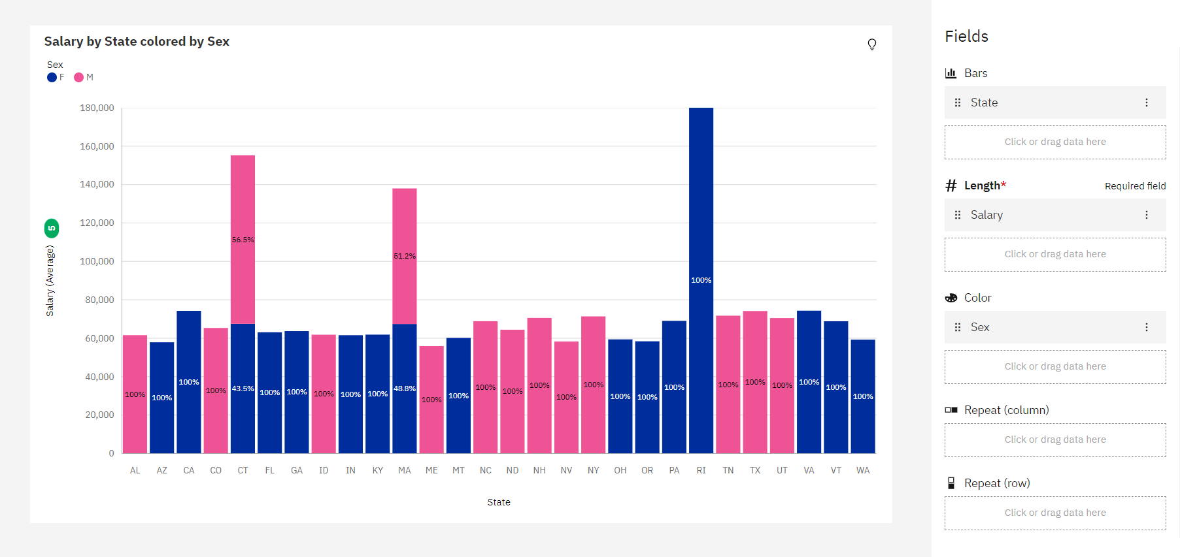

**Radial Chart: -**

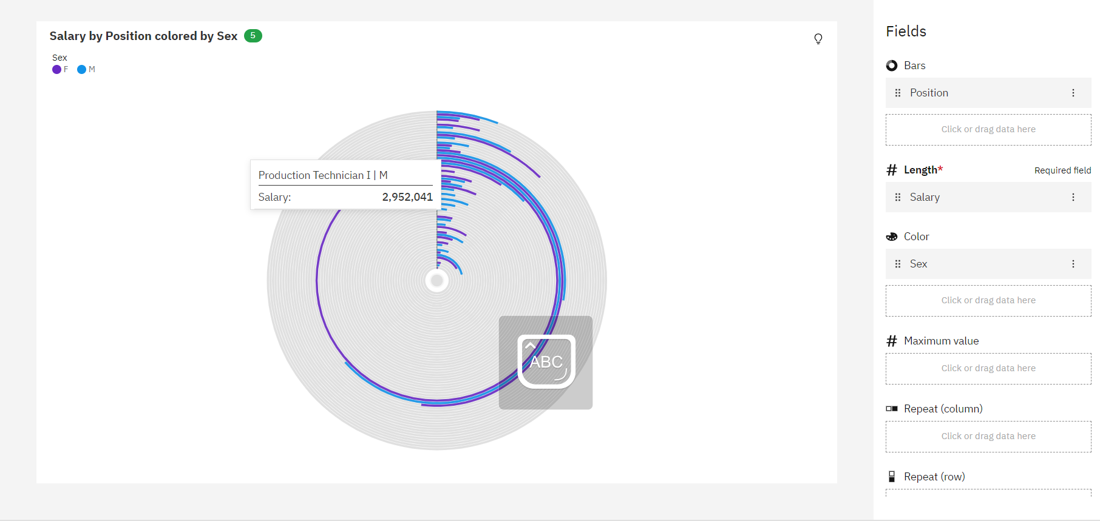

**Hierarchy Bubble Chart: -**

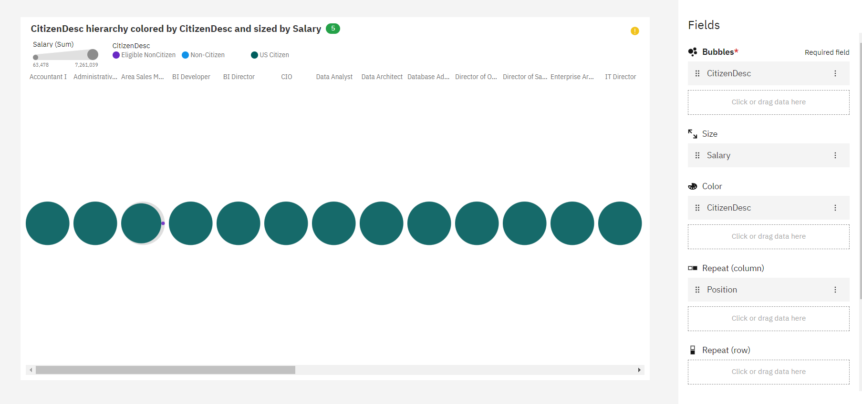

**Heat Map Chart: -**

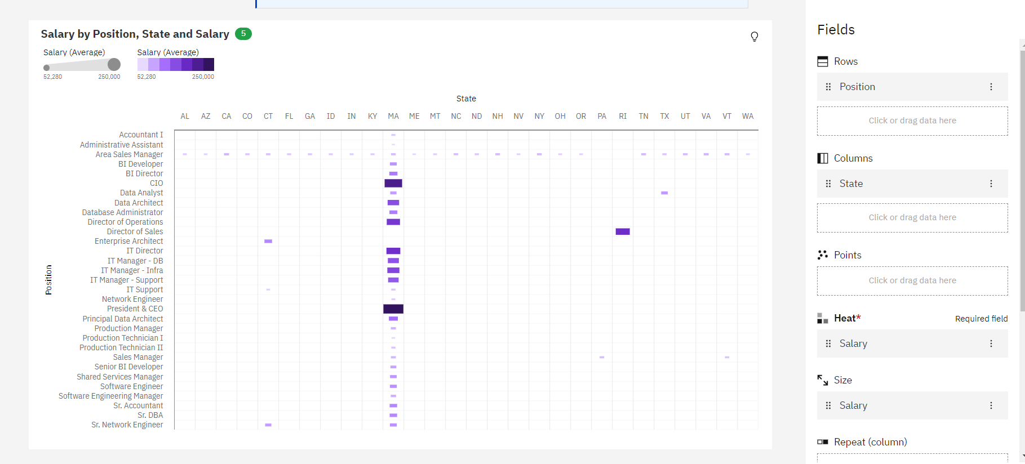

**Dash Board: -**

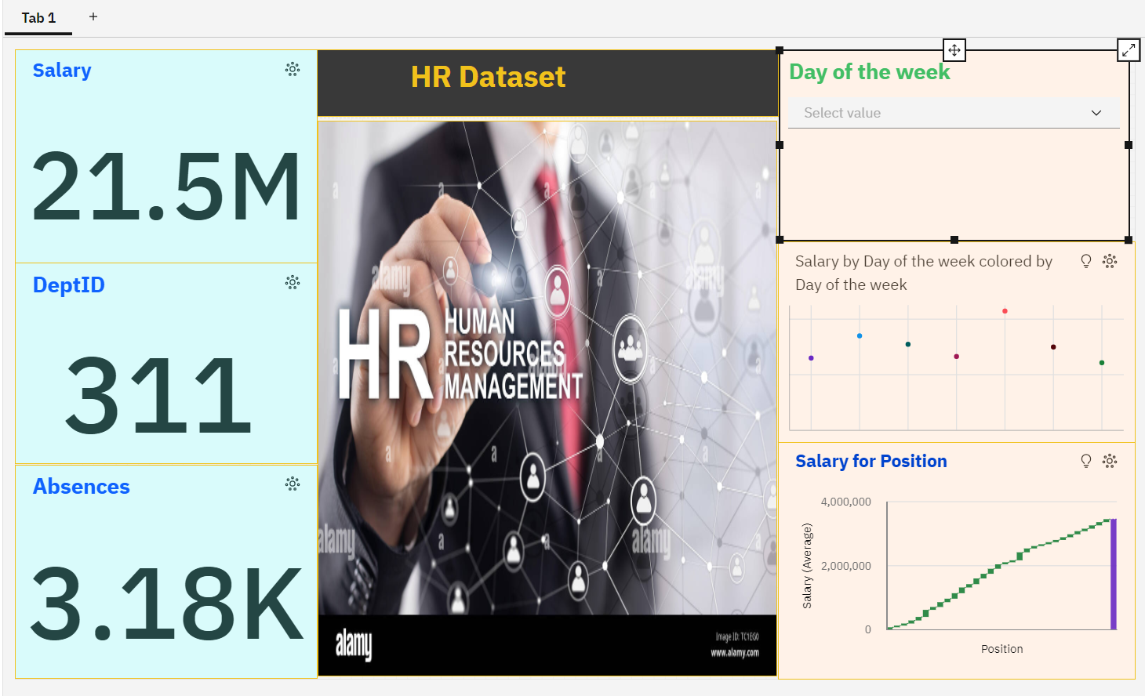

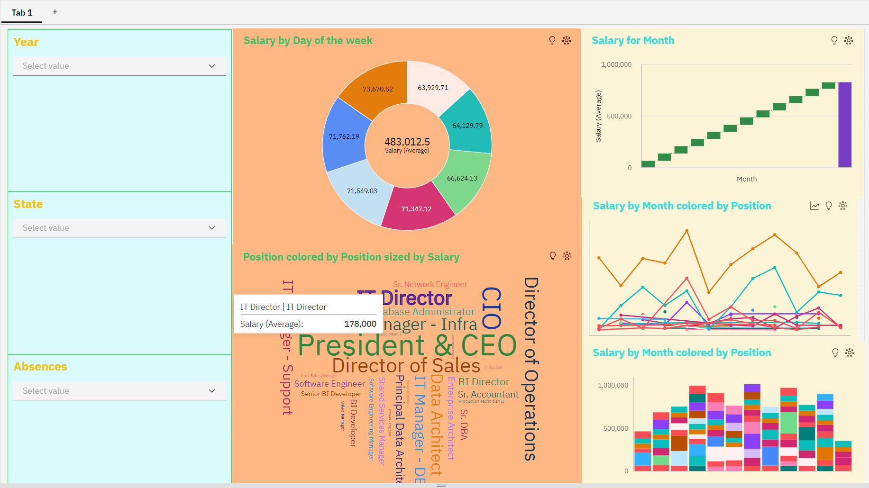

**Report:-**

**Story:-**

**1)**

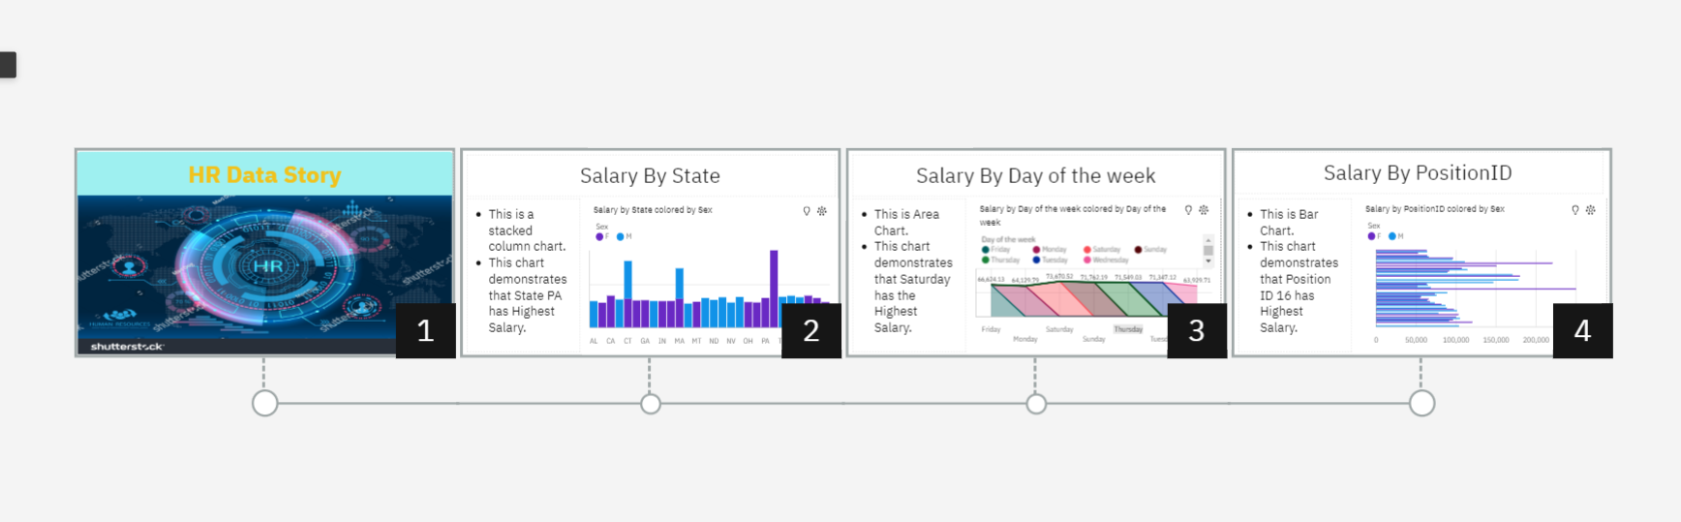

**2)**

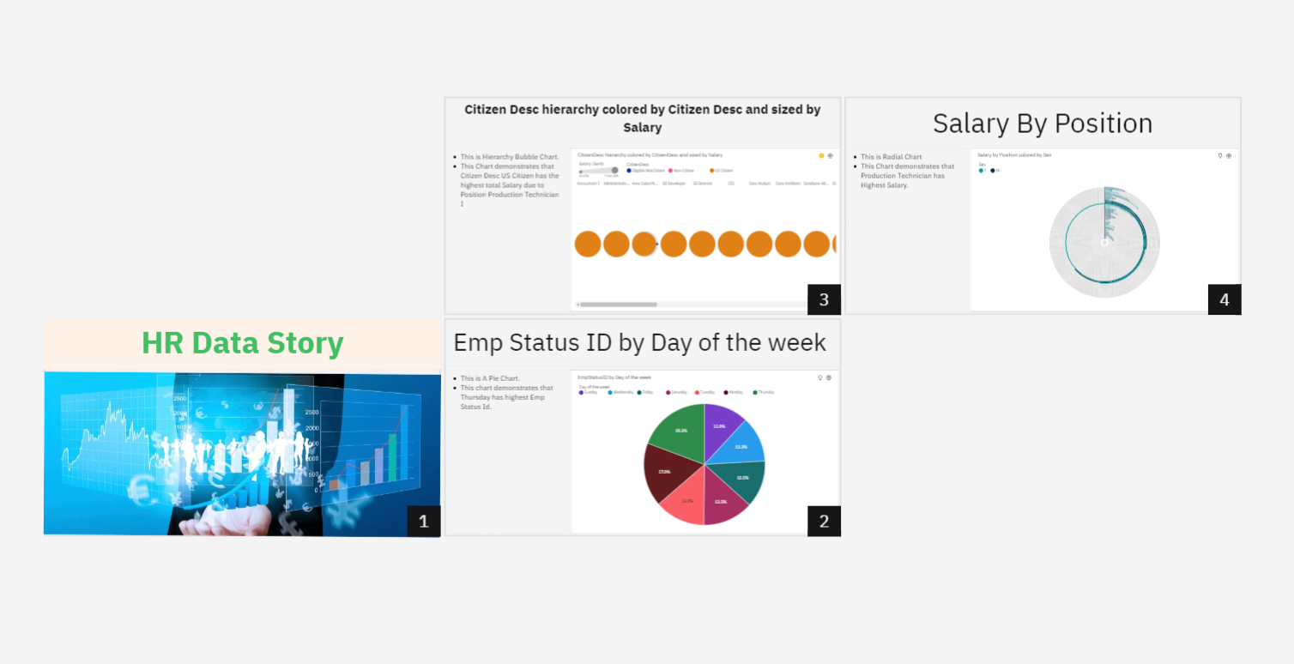

**3)**

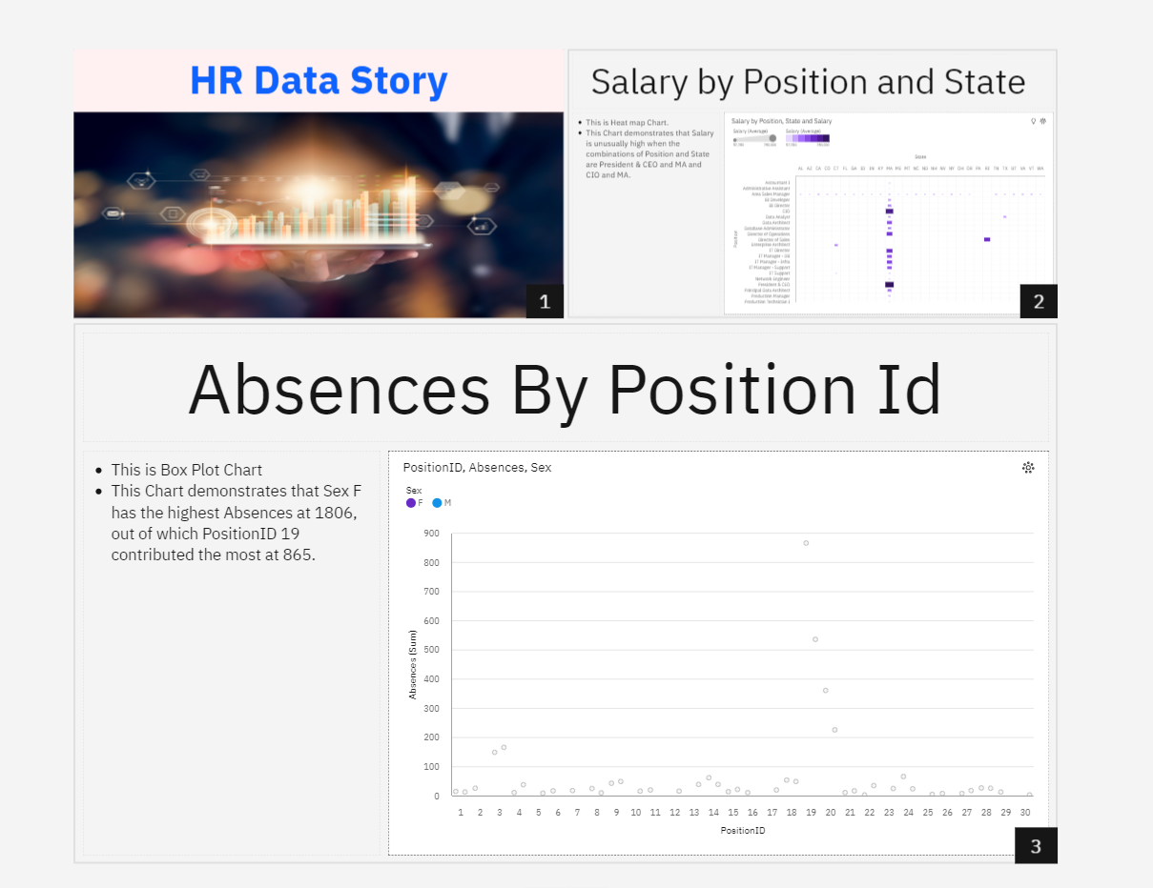

**4)**

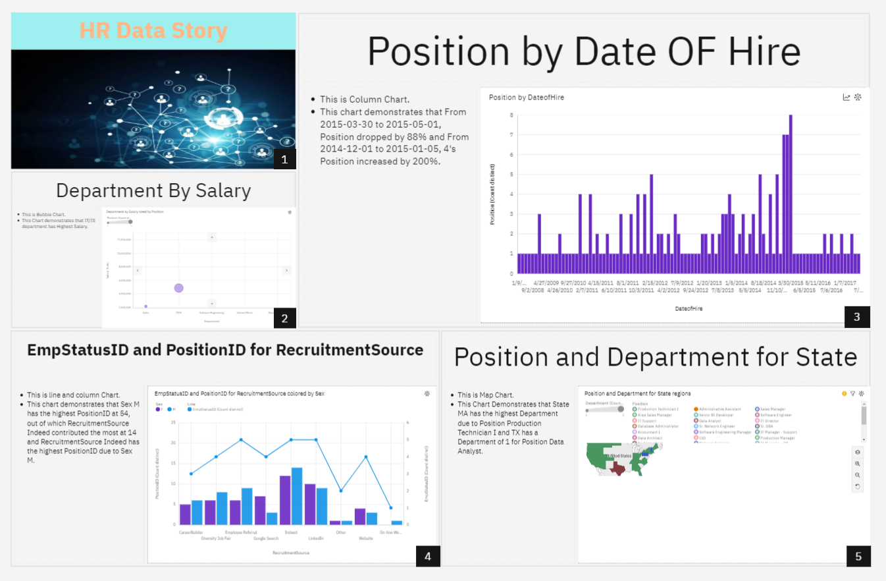

**5)**

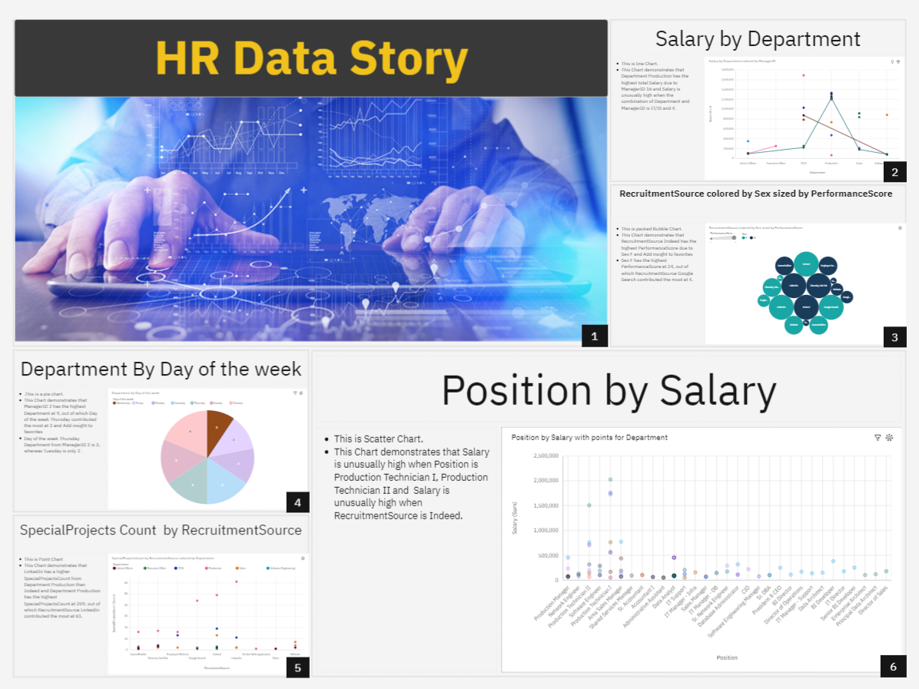

**6)**

